**(Q) What is jQuery?**

**A.** jQuery is a fast, small, and feature-rich java-script library that simplifies and enhances the process of interacting with HTML document, handling events, creating animations, and performing other common tasks on the web.

**(Q) How to Apply CSS Using jQuery, How to Add Class and Remove Class in jQuery, jQuery Animation?**

**A.**

**--------------CSS Using jQuery-------------**

You can use jQuery to apply CSS styles to HTML elements. The ‘.css()’ method is used to get or set the CSS properties of an element.

**CSS input:**

<!DOCTYPE html>

<html lang="en">

<head>

    <meta charset="UTF-8">

    <meta name="viewport" content="width=device-width, initial-scale=1.0">

    <title>Document</title>

    <script src="https://cdnjs.cloudflare.com/ajax/libs/jquery/3.7.0/jquery.min.js"></script>

</head>

<body>

    <p id="one">welcome</p>

    <script>

        $(document).ready(function () {

            $("#one").css({"color":"aqua","font-size": "80px", "background-color":"brown"})

        })

    </script>

</body>

</html>

**CSS Output:**



**------------Add class and Remove class---------**

You can use the ‘.addClass()’ and ‘.removeClass()’ methods to add and remove classes from HTML elements using jQuery.

**Input:**

<!DOCTYPE html>

<html lang="en">

<head>

    <meta charset="UTF-8">

    <meta name="viewport" content="width=device-width, initial-scale=1.0">

    <title>Document</title>

    <script src="https://cdnjs.cloudflare.com/ajax/libs/jquery/3.7.0/jquery.min.js"></script>

    <style>

        .one{

            background-color: yellowgreen;

        }

    </style>

</head>

<body>

    <p id="one">welcome</p>

    <button id="two">add</button>

    <button id="three">remove</button>

    <script>

        $(document).ready(function () {

            $("#two").click(function () {

                $("#one").addClass("one")

            })

            $("#three").click(function () {

                $("#one").removeClass("one")

            })

        })

    </script>

</body>

</html>

**Add Class Output:**

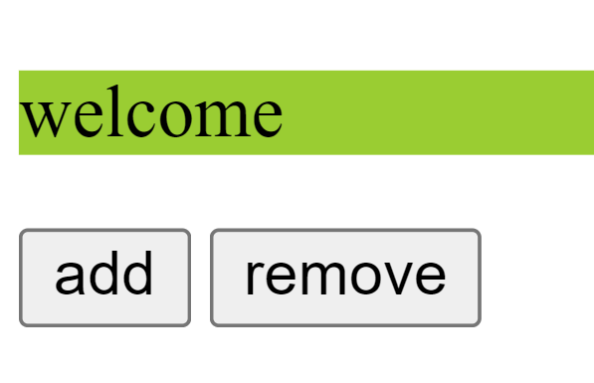

**Remove Class Output:**

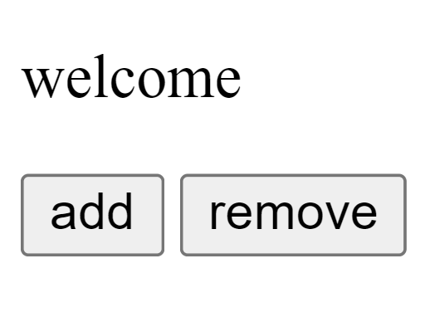

**--------------Animation in jQuery----------------**

You can use the ‘.animate()’ methods to create animation in HTML using jQuery.

**Input:**

<!DOCTYPE html>

<html lang="en">

<head>

    <meta charset="UTF-8">

    <meta name="viewport" content="width=device-width, initial-scale=1.0">

    <title>Document</title>

    <script src="https://cdnjs.cloudflare.com/ajax/libs/jquery/3.7.0/jquery.min.js"></script>

    <style>

        #one{

            height: 150px;

            width: 150px;

            background-color: blueviolet;

            position: relative;

        }

    </style>

</head>

<body>

    <p id="one">welcome</p>

    <button id="two">Animation</button>

    <script>

        $(document).ready(function () {

            $("#two").click(function () {

                $("#one").animate({"left": "20%"})

            })

        })

    </script>

</body>

</html>

**Before animation Output:**



**After animation Output:**



**(Q) How to create slider with animation?**

**A.**

**Input:**

<!DOCTYPE html>

<html lang="en">

<head>

    <meta charset="UTF-8">

    <meta name="viewport" content="width=device-width, initial-scale=1.0">

    <title>Document</title>

    <script src="https://cdnjs.cloudflare.com/ajax/libs/jquery/3.7.0/jquery.min.js"></script>

</head>

<body>

   <div class="slider">

    <img src="https://th.bing.com/th?id=OIP.WZpJWGQijdTLdd6E2ZaDUAHaFj&w=288&h=216&c=8&rs=1&qlt=90&o=6&pid=3.1&rm=2" alt="">

    <img src="https://th.bing.com/th?id=OIP.RtMOLmPJxYLAvaFp7-U7SgHaJQ&w=223&h=279&c=8&rs=1&qlt=90&o=6&pid=3.1&rm=2" alt="">

    <img src="https://th.bing.com/th?id=OIP.WpRmFAMvZIWjJQW3TGSktgHaEo&w=316&h=197&c=8&rs=1&qlt=90&o=6&pid=3.1&rm=2" alt="">

   </div>

   <script>

    $(document).ready(function () {

        var $slider = $('.slider');

        var $slides = $slider.find('img');

        var currentslide = 0;

        function showslide(index) {

            $slides.eq(index).css('opacity', 1);

            $slides.not(':eq(' + index +')').css('opacity', 0);

        }

        function nextslide() {

            currentslide = (currentslide + 1) % $slides.length;

            showslide(currentslide);

        }

         setInterval(nextslide, 3000);

    });

   </script>

</body>

</html>

**Slider:**

